Name: | ___________________________________________________ |  |  |  | Date: ___________
 | Year 8 Mathematics  Investigation 3, 2013  Topic – Linear Functions  Take home component
Date out: |  | Week ____ Date _____________ | Date Due: | Week ____ Date _____________
Take home component weighting: |  | 0% of the year | In-class component weighting: | 7% of the year.
AIM: In this assessment, you will be investigating linear functions, rules and graphs, and apply these skills to an everyday situation

One wet, winter day, Jamie found a pile of matchsticks in the kitchen cupboard. As he couldn’t play football outside, he decided to create a pattern using them.

Below are the first three shapes in his pattern:

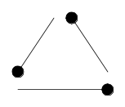 | 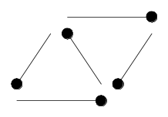 | 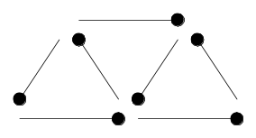
Shape 1 | Shape 2 | Shape 3

1. | Draw the next three shapes in the pattern:
 | Shape 4
 | Shape 5
 | Shape 6

2. | Complete the table below by writing in the number of matchsticks needed to create each shape:
Shape number (N) | 1 |  | 2 |  | 3 |  | 4 |  | 5 |  | 6
Number of matches (M)
Work out the differences between successive patterns

3. | Describe the pattern of differences.

4. | Working mathematically, is there a RULE to calculate the number of matches needed for a particular shape number? Write your answer in words.

5. | Complete the word equation by studying the pattern and the table of values.  Total number of matches =_________ × shape number + ________

6. | Instead of using words, mathematicians prefer to use symbols –  M is the number of matches and N is the shape number  So instead of using words, the rule is written as:

7. | Plot the points shown in the table and join them to form a graph of this relationship. Don’t forget to label your axes.
 | 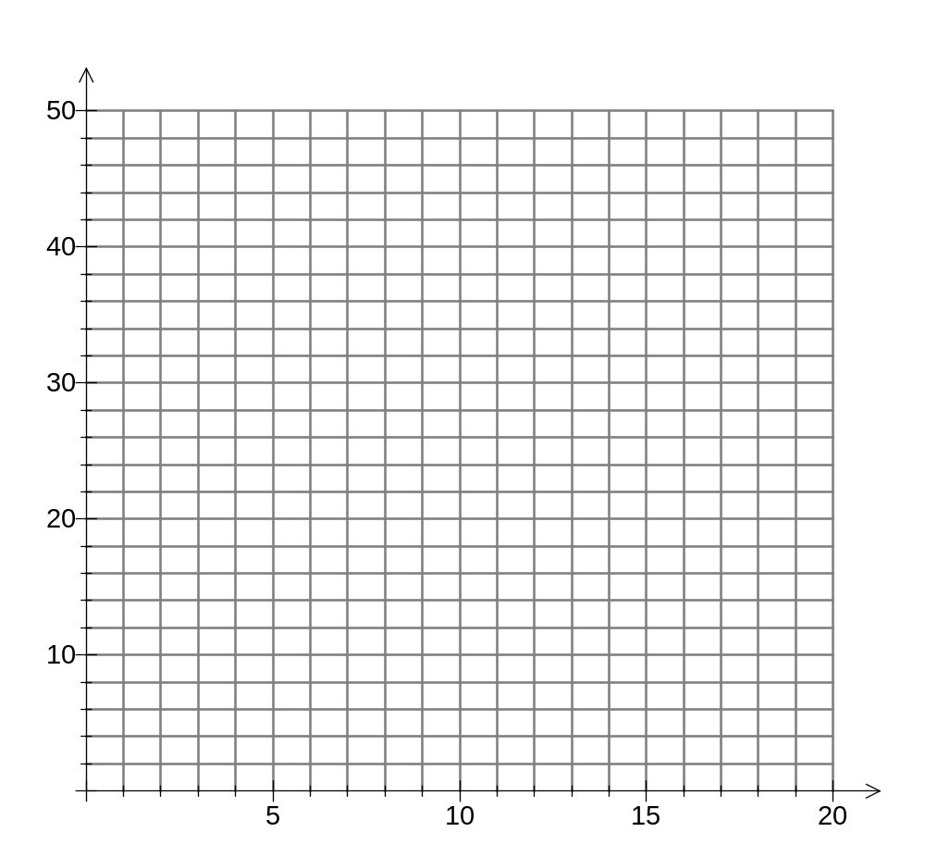

8. | Is the relationship linear? How can you tell?

9. | a) | From the graph above, predict how many matchsticks will be needed to create Shape 10.
 | b) | Use your rule from Question 6 to check your answer. Was the answer the same as your prediction?

10. | a) | From the graph above, predict which shape number will be built with 31 matchsticks.
 | b) | Use your rule from Question 6 to check your answer. Was the answer the same as your prediction?

Jamie’s older brother, Jake came into the kitchen and wanted to create his own pattern on the same rainy day.

Below are the first three shapes in his pattern:

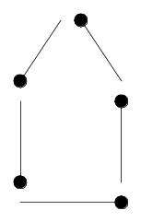 | 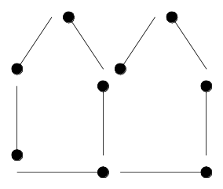 | 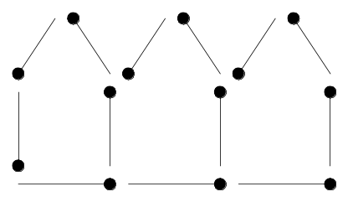
Shape 1 | Shape 2 | Shape 3

11. | Draw the next three shapes in the pattern:
 | Shape 4
 | Shape 5
 | Shape 6

12. | Complete the table below by writing in the number of matchsticks needed to create each shape:
Shape number (N) | 1 |  | 2 |  | 3 |  | 4 |  | 5 |  | 6
Number of matches (M)
Work out the differences between successive patterns

13. | Describe the pattern of differences.

14. | Working mathematically, is there a RULE to calculate the number of matches needed for a particular shape number? Write your answer in words.

15. | Complete the word equation by studying the pattern and the table of values.  Total number of matches =_________ × shape number + ________

16. | Instead of using words, mathematicians prefer to use symbols –  M is the number of matches and N is the shape number  So instead of using words, the rule is written as:

17. | Plot the points shown in the table and join them to form a graph of this relationship. Don’t forget to label your axes.

18. | Is the relationship linear? How can you tell?

19. | Compare the graph above to the graph in Question 7. What do they have in common? What are their differences?

20. | a) | From the graph above, predict how many matchsticks will be needed to create Shape 10.
 | b) | Use your rule from Question 16 to check your answer. Was the answer the same as your prediction?

21. | a) | From the graph above, predict which shape number will be built with 49 matchsticks.
 | b) | Use your rule from Question 16 to check your answer. Was the answer the same as your prediction?

Jamie and Jake’s dad, John, came into the kitchen to get a glass of water and noticed what the boys were doing. He decided they needed a bit of a challenge and created his own challenge.

John started with this shape:

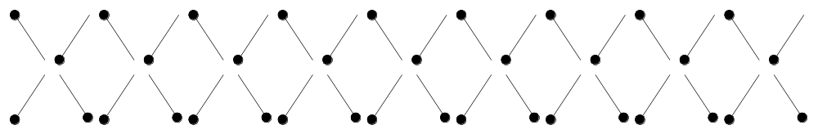
Shape 1

He then told his sons that his pattern was to take two matches away each time.

22. | Draw the next three shapes in the pattern:
 | Shape 2
 | Shape 3
 | Shape 4

23. | Complete the table below by writing in the number of matchsticks needed to create each shape:
Shape number (N) | 1 |  | 2 |  | 3 |  | 4 |  | 5 |  | 6
Number of matches (M)
Work out the differences between successive patterns

24. | Describe the pattern of differences.

25. | Working mathematically, is there a RULE to calculate the number of matches needed for a particular shape number? Write your answer in words.

26. | Complete the word equation by studying the pattern and the table of values.  Total number of matches =_________ × shape number + ________

27. | Instead of using words, mathematicians prefer to use symbols –  M is the number of matches and N is the shape number  So instead of using words, the rule is written as:

28. | Plot the points shown in the table and join them to form a graph of this relationship. Don’t forget to label your axes.

29. | Is the relationship linear? How can you tell?

30. | Compare the graph above to the graphs in Question 7 and Question 17. What do they have in common? What are their differences?

31. | a) | From the graph above, predict how many matchsticks will be needed to create Shape 7.
 | b) | Use your rule from Question 27 to check your answer. Was the answer the same as your prediction?

32. | a) | From the graph above, predict which shape number will have no matches in it.
 | b) | Use your rule from Question 27 to check your answer. Was the answer the same as your prediction?

~ END OF TAKE HOME COMPONENT ~

